Faculty of Computing



**[Computer Communications & Network]**

**Lab No 4 Tasks**

**Task 1:** Connect 4 PCs with the HUB in cisco packet tracer and send data from PC 1 to PC 2 and check the working of HUB through simulation mode. (05 Marks)

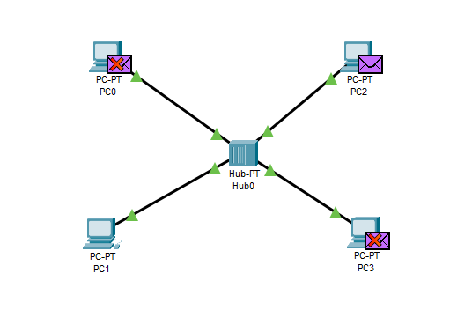

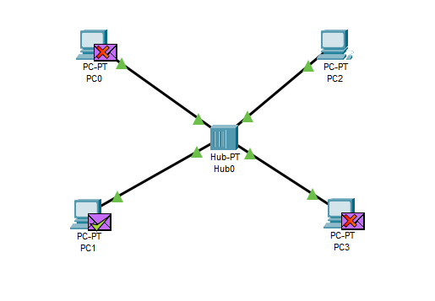

**Task 2:** Connect 4 PCs with the SWITCH in cisco packet tracer and send data from PC 1 to PC 2 and check the working of SWITCH through simulation mode. (05 Marks)

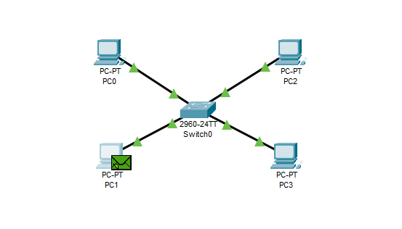

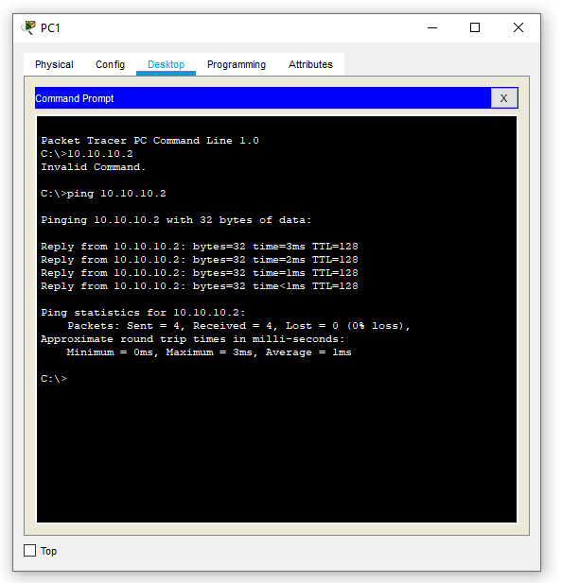

**Note: Save all the cisco packets files for reference in the next lab. Create a word document and attach screenshots of all the simulations under each task for evaluation.**